**1. Type the following program and execute it. Can you tell from the result what the command**

**DBMS_OUTP**

**The command DBMS_OUTPUT.PUT_LINE is used to display output in PL/SQL. When executed, the given PL/SQL program will print today's date.**

**Today's date is**

**<current system date>**

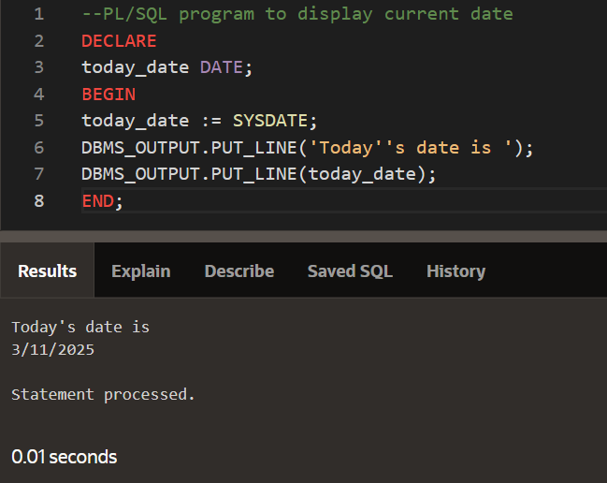

**2. Before you begin to work on the following questions, first download createDB.sql from**

**the course website and execute it.**

**Read the following program and figure out what it does. Then type it and execute it to verify**

**if you are right.**

**The given PL/SQL program calculates and displays the number of students who received an "A" in the gradeReport table. If there are students with an "A" grade, it prints the total count; otherwise, it displays "No student makes an A."ays "No student makes an A."**

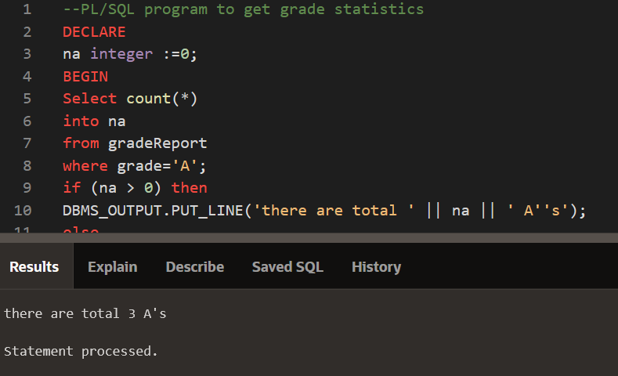

**3. Revise the above program, so that it will output the statistics for the grades A, B, C, D, and F.**

**DECLARE**

**na INTEGER := 0;**

**nb INTEGER := 0;**

**nc INTEGER := 0;**

**nd INTEGER := 0;**

**nf INTEGER := 0;**

**BEGIN**

**SELECT COUNT(*) INTO na FROM gradeReport WHERE grade = 'A';**

**SELECT COUNT(*) INTO nb FROM gradeReport WHERE grade = 'B';**

**SELECT COUNT(*) INTO nc FROM gradeReport WHERE grade = 'C';**

**SELECT COUNT(*) INTO nd FROM gradeReport WHERE grade = 'D';**

**SELECT COUNT(*) INTO nf FROM gradeReport WHERE grade = 'F';**

**DBMS_OUTPUT.PUT_LINE('Total A''s: ' || na);**

**DBMS_OUTPUT.PUT_LINE('Total B''s: ' || nb);**

**DBMS_OUTPUT.PUT_LINE('Total C''s: ' || nc);**

**DBMS_OUTPUT.PUT_LINE('Total D''s: ' || nd);**

**DBMS_OUTPUT.PUT_LINE('Total F''s: ' || nf);**

**END;**

**Expected out put**

**Total A's: 5**

**Total B's: 10**

**Total C's: 8**

**Total D's: 3**

**Total F's: 2**

